API Ecosystem

🌟 Definition
# Source: AI Source: Provided by: [Data Path: Persons Table -> ID Column: 1, Name_En Column: Motasem Essam] -> From: [ChatGPT] on [5/31/2026]
An API Ecosystem is the complete network of APIs, platforms, tools, services, standards, providers, developers, applications, and users that interact to create, manage, share, and consume APIs.
It represents the entire environment in which APIs are developed, published, managed, integrated, and used.

🎯 Purpose
# Source: AI Source: Provided by: [Data Path: Persons Table -> ID Column: 1, Name_En Column: Motasem Essam] -> From: [ChatGPT] on [5/31/2026]
- To enable communication between software systems
- To support API development and management
- To connect service providers and consumers
- To encourage software integration and innovation
- To create interoperable digital systems

🏗️ Main Components of an API Ecosystem

1. API Providers
# Source: AI Source: Provided by: [Data Path: Persons Table -> ID Column: 1, Name_En Column: Motasem Essam] -> From: [ChatGPT] on [5/31/2026]
Organizations or developers that create and publish APIs.
Examples
- AI service providers
- Payment service providers
- Cloud service providers
- Social media platforms

2. API Platforms
# Source: AI Source: Provided by: [Data Path: Persons Table -> ID Column: 1, Name_En Column: Motasem Essam] -> From: [ChatGPT] on [5/31/2026]
Platforms that provide APIs as services.
Examples
- OpenAI Platform
- Stripe Developers Platform
- Google Cloud APIs

3. API Development & Collaboration Platforms
# Source: AI Source: Provided by: [Data Path: Persons Table -> ID Column: 1, Name_En Column: Motasem Essam] -> From: [ChatGPT] on [5/31/2026]
Platforms used to design, test, document, and manage APIs.
Examples
- Postman
- Swagger Hub
- Stoplight

4. API Management Platforms
# Source: AI Source: Provided by: [Data Path: Persons Table -> ID Column: 1, Name_En Column: Motasem Essam] -> From: [ChatGPT] on [5/31/2026]
Platforms that control, secure, and monitor APIs.
Examples
- AWS API Gateway
- Apigee
- Azure API Management

5. API Consumers
# Source: AI Source: Provided by: [Data Path: Persons Table -> ID Column: 1, Name_En Column: Motasem Essam] -> From: [ChatGPT] on [5/31/2026]
Applications or services that use APIs.
Examples
- Mobile apps
- Websites
- Enterprise systems
- IoT devices

6. API Standards and Specifications
# Source: AI Source: Provided by: [Data Path: Persons Table -> ID Column: 1, Name_En Column: Motasem Essam] -> From: [ChatGPT] on [5/31/2026]
Rules that allow APIs to work consistently.
Examples
- REST
- GraphQL
- OpenAPI
- gRPC
- SOAP

7. Developers and Organizations
# Source: AI Source: Provided by: [Data Path: Persons Table -> ID Column: 1, Name_En Column: Motasem Essam] -> From: [ChatGPT] on [5/31/2026]
People and companies that build and use APIs.
Roles
- API designers
- Backend developers
- Frontend developers
- DevOps engineers
- System architects

🔄 How an API Ecosystem Works
# Source: AI Source: Provided by: [Data Path: Persons Table -> ID Column: 1, Name_En Column: Motasem Essam] -> From: [ChatGPT] on [5/31/2026]
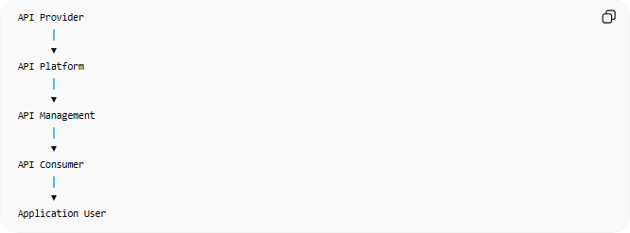
API Provider
│
▼
API Platform
│
▼
API Management
│
▼
API Consumer
│
▼
Application User
Supporting all stages:
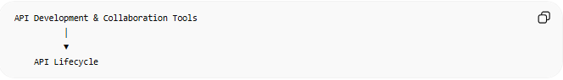
API Development & Collaboration Tools
│
▼
API Lifecycle

📚 Example Ecosystem
# Source: AI Source: Provided by: [Data Path: Persons Table -> ID Column: 1, Name_En Column: Motasem Essam] -> From: [ChatGPT] on [5/31/2026]
Suppose a mobile application uses:
- OpenAI Platform for AI features
- Stripe Developers Platform for payments
- Postman for API testing
- AWS API Gateway for API management
Together, these components form part of a larger API ecosystem.

🔗 Relationship to Other Concepts
# Source: AI Source: Provided by: [Data Path: Persons Table -> ID Column: 1, Name_En Column: Motasem Essam] -> From: [ChatGPT] on [5/31/2026]
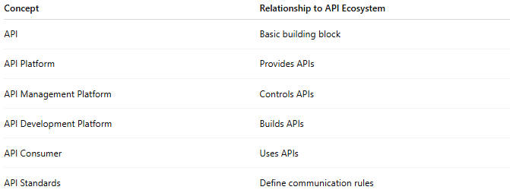
Concept | Relationship to API Ecosystem
API | Basic building block
API Platform | Provides APIs
API Management Platform | Controls APIs
API Development Platform | Builds APIs
API Consumer | Uses APIs
API Standards | Define communication rules

🧠 Simple Analogy
# Source: AI Source: Provided by: [Data Path: Persons Table -> ID Column: 1, Name_En Column: Motasem Essam] -> From: [ChatGPT] on [5/31/2026]
Think of an API ecosystem like a transportation ecosystem:
- Roads = APIs
- Vehicle manufacturers = API providers
- Traffic control systems = API management
- Navigation tools = API development tools
- Drivers = developers
- Passengers = end users
All parts work together to enable movement and communication.

🧭 Summary
# Source: AI Source: Provided by: [Data Path: Persons Table -> ID Column: 1, Name_En Column: Motasem Essam] -> From: [ChatGPT] on [5/31/2026]
An API Ecosystem is the complete environment surrounding APIs, including API providers, API platforms, development tools, management systems, standards, developers, applications, and users. It is the broadest concept that encompasses everything involved in creating, managing, and using APIs.

